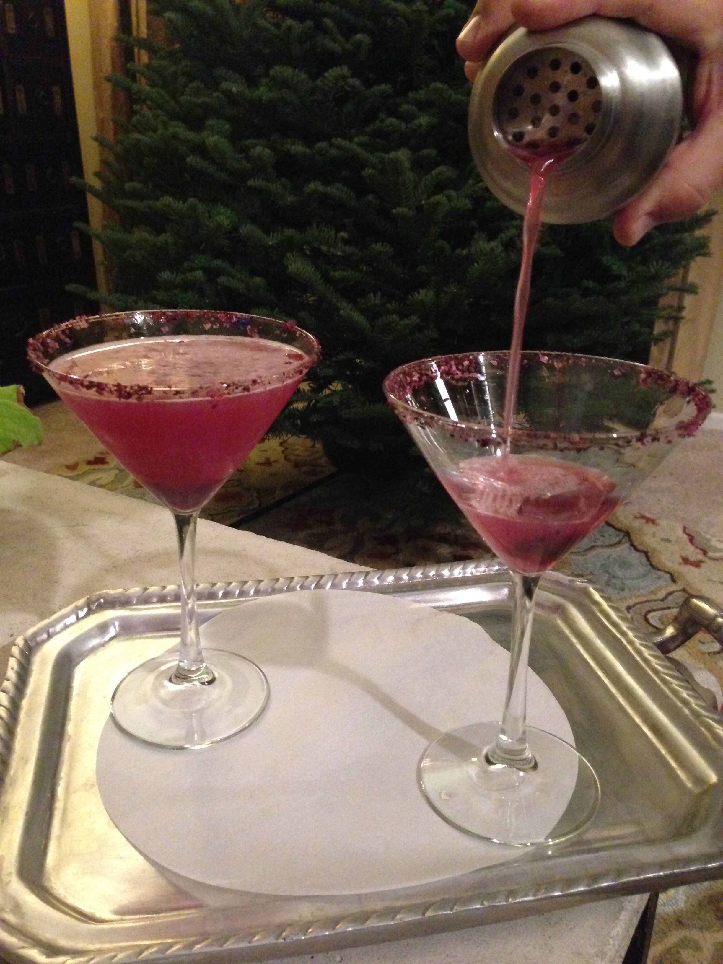
Holiday Hibiscus Cranberry Margarita

Yield: 1 Serving

Fine mesh strainer
One 8-oz martini glass
Martini shaker
Ice

1 8.8 oz jar *Wild Hibiscus Flowers in Syrup

1. Take and strain flowers and syrup. Save the syrup do not discard.

1 3.5 oz pkg **Wild Hibiscus Flower Pyramid Salt Flakes

1. Take a sprinkle a bit of the salt on a plate. Roll the edge of the martini glass that has been moisten with water so it sticks to the rim.

1 each wild hibiscus flower, patted dry and chopped
5 oz cranberry juice
1-1/2 oz vodka
1 tbsp syrup from hibiscus flowers
1/4 oz freshly squeezed lime juice

- Place chopped flower into prepared martini glass.

- In a martini shaker that is packed with ice, add cranberry juice, vodka, syrup and lime juice. Shake until the outside of shaker is ice cold.

- Strain into prepared glass.

*You can find these at BevMo stores in the specialty section
** You can purchase these online at www.hibiscus-salt.com

